# Blast Off – 3 Parts

* Build the rocket parts by tracing the shape with your Evo
* Since Evo picks a random direction when it comes to a line intersection, you will need to use Color Codes to tell it where to go
* Place a “Win and Stop” code at the end when you believe it will be done tracing the part
* When you think you have it working, show it to a Leader for confirmation – then you’ll receive your next part

### Part #1

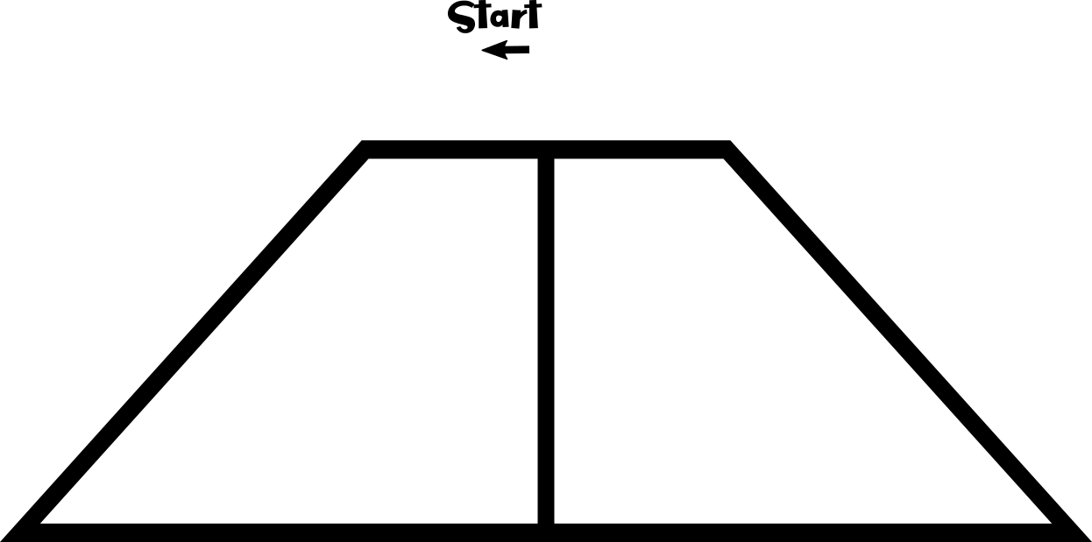

### Part #2

### Part #3

